**MODULE: 1**

1. **What is software? What is software engineering?**

* **Software :**

-Software is a set of instructions, data or programs used to operate computers and execute specific tasks.

-Software is a generic term used to refer to applications, [scripts](https://www.techtarget.com/whatis/definition/script) and programs that run on a device.

* **software engineering :**

-Software engineering is the process of developing, testing and deploying computer...

1. **Explain types of software**
2. **Application software :**

- The most common type of software, application software is a computer

software package that performs a specific function for a user, or in some

cases, for another application.

- An application can be self-contained, or it can be a group of programs that

run the application for the user.

- Examples of Modern Applications include office suites, graphics software,

databases and database management programs, web browsers, word

processors, software development tools, image editors and communication

platforms.

Example:Microsoft Office, Paint, Powerpoint etc..

1. **System software :**

- These software programs are designed to run a computer's application

programs and hardware.

- System software coordinates the activities and functions of the hardware

and software.

- It controls the operations of the computer hardware and provides an

environment or platform for all the other types of software to work in.

- The OS is the best example of system software; it manages all the other

computer programs.

- Other examples of system software include the firmware, computer

language translators and system utilities..

Example:Notepad ,Calculator etc..

1. **Driver software :**

- Also known as device drivers, this software is often considered a type of

system software.

- Device drivers control the devices and peripherals connected to a computer,

enabling them to perform their specific tasks.

- Every device that is connected to a computer needs at least one device

driver to function.

- Examples include software that comes with any nonstandard hardware,

including special game controllers, as well as the software that enables

standard hardware, such as USB storage devices, keyboards, headphones

and printers.

Example: Audio Driver,Video Driver etc..

1. **Middleware :**

- The term middleware describes software that mediates between application

and system software or between two different kinds of application software.

For example, middleware enables Microsoft Windows to talk to Excel and

Word.

- It is also used to send a remote work request from an application in a

computer that has one kind of OS, to an application in a computer with a

different OS. It also enables newer applications to work with legacy ones.

Example: database middleware,application server middleware

1. **Programming software :**

- Computer programmers use programming software to write code.

Programming software and programming tools enable developers to

develop, write, test and debug other software programs.

- Examples of programming software include assemblers, compilers,

debuggers and interpreters.

Examples : Turbo c,Eclipse,Sublime etc.

1. **What is SDLC? Explain each phase of SDLC**

The Software Development Life Cycle (SDLC) refers to a methodology

with clearly defined processes for creating high-quality software. in

detail, the SDLC methodology focuses on the following phases of

software development:

1. Requirement Gathering

2. Analysis

3. Designing

4. Implementation

5. Testing

6. Maintenance

1. **Requirement Gathering :**

* During this phase, all the relevant information is collected from the customer to develop a product as per their expectation. Any ambiguities must be resolved in this phase only.
* Business analyst and Project Manager set up a meeting with the customer to gather all the information like what the customer wants to build, who will be the end-user, what is the purpose of the product. Before building a product a core understanding or knowledge of the product is very important.
* **For Example:** A customer wants to have an application which involves money transactions. In this case, the requirement has to be clear like what kind of transactions will be done, how it will be done, in which currency it will be done, etc.

1. **Analysis :**

* Once the requirement gathering is done, an analysis is done to check the feasibility of the development of a product. In case of any ambiguity, a call is set up for further discussion.
* Once the requirement is clearly understood, the SRS (Software Requirement Specification) document is created. This document should be thoroughly understood by the developers and also should be reviewed by the customer for future reference.

1. **Designing :**

* In this phase, the requirement gathered in the SRS document is used as an input and software architecture that is used for implementing system development is derived.

1. **Implementation :**

* Implementation/Coding starts once the developer gets the Design document. The Software design is translated into source code. All the components of the software are implemented in this phase.

1. **Testing :**

* Testing starts once the coding is complete and the modules are released for testing. In this phase, the developed software is tested thoroughly and any defects found are assigned to developers to get them fixed.
* Retesting, regression testing is done until the point at which the software is as per the customer’s expectation. Testers refer SRS document to make sure that the software is as per the customer’s standard.

1. **Maintenance :**

* maintenance of the product i.e. if any issue comes up and needs to be fixed or any enhancement is to be done is taken care by the developers.

1. **What is DFD? Create a DFD diagram on Flipkart**

* A data flow diagram (DFD) is a graphical or visual representation using a standardized set of symbols and notations to describe a business's operations through data movement.

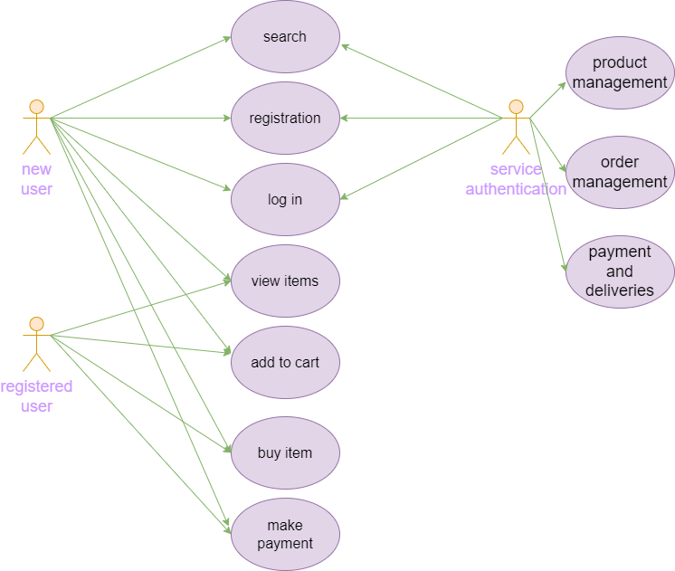

1. **What is Flow chart? Create a flowchart to make addition of two numbers**

* A **flowchart** is a picture of the separate steps of a process in sequential order. It is a generic tool that can be adapted for a wide variety of purposes, and can be used to describe various processes, such as a manufacturing process, an administrative or service process, or a project plan.
* **Flowchart to addition of two numbers :**

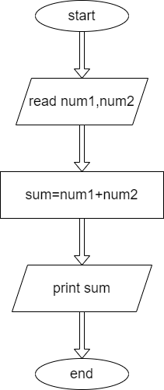

1. **What is Use case Diagram? Create a use-case on bill payment on paytm.**

* A use case diagram is a visual summarization of interactions and relationships within a system. These diagrams show a very broad view of a system. They may show systems in computer software, businesses or customer experiences. A use case diagram shows a model scenario in which individuals interact with a system using a series of specialized symbols and connectors.

